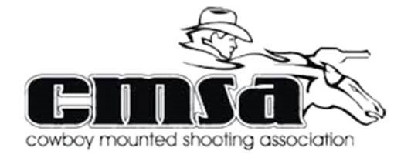
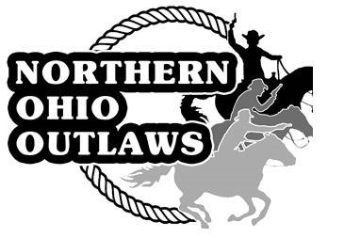
Northern Ohio Outlaws

Cowboy Mounted Shooting

2023 Competition Season Sponsorship

Come Ride Fast and Shoot Straight with the Outlaws

Cowboy Mounted Shooting is the fastest growing equestrian sport in the nation. Contestants compete on horseback using two 45 caliber single action revolvers, each loaded with five rounds of specially prepared black powder blank ammunition. Mounted Shooting is a competitive sport with multiple levels of competition ranging from beginner to advanced (1-6) as well as a youth division known as wranglers.

The Northern Ohio Outlaws is affiliated with the Cowboy Mounted Shooting Association (CMSA) and is comprised of members throughout Ohio and neighboring states. Each year the club hosts events throughout the year such as new-shooter clinics, demos and CMSA sanctioned competitions. For the past several years we have had to opportunity to host the Ohio State Championship shoot. Competitions typically draw upwards of 100+ competitors as well as spectators from all over the country to the Wayne County Fairgrounds in Wooster, Ohio.

As our membership continues to grow it creates an outstanding opportunity for organizations such as yours to receive recognition through sponsorship. Financial support and product donation will gain you direct advertising opportunities to individuals who shop at your businesses. We welcome any form of sponsorships.

Thank you for considering a sponsorship with the Northern Ohio Outlaws. We look forward to building a partnership with you as well as the opportunity to promote your business at our events for the upcoming competition season. Please consider one of our current sponsorship packages listed on one of the following pages.

Sincerely,
The Northern Ohio Outlaws, CMSA

BASIC SPONSORSHIP LEVELS

* Basic sponsors will receive an invitation to our year-end awards banquet at a reduced rate and will be recognized during the awards ceremony.

$150-$249 Associate of the Northern Ohio Outlaws Shooters Sponsorship

- Special mention at all NOO events
- Up to a 3’ tall banner (any length) supplied by sponsor with company logo at all Northern Ohio Outlaws events
- Image of business card on website
- Company logo and special URL link to sponsor site on NOO Website
- Invitation to year-end club awards banquet for recognition (at discounted rate)

$250 - $499 Friend of the Northern Ohio Outlaws Shooters Sponsorship

- Associate level plus the following:
- Small business image on sponsor page
- Opportunity to sell/promote products at all NOO events. Vendor fee will be waived
- 1 Day Shoot named after your company.
- Invitation to year-end club awards banquet for recognition (at discounted rate)

$500 - $999 Patron of the Northern Ohio Outlaws Sponsorship

- Friend level plus the following:
- Sponsorship Appreciation Plaque
- Complimentary invite to year end banquet for recognition

EXCLUSIVE SPONSORSHIP LEVELS

* Exclusive sponsors receive a Northern Ohio Outlaws Sponsorship plaque and a complimentary invite to the year-end awards banquet for special recognition.

$1000 - $1999 Silver Level

- Patron sponsor level plus the following:
- Barrel cover with the company logo supplied by NOO
- *Exclusive sponsor

$2000 - $2999 Gold Level

- Bronze Sponsor Level plus the following:
- Shoot named after your organization for the entire weekend (State Shoot excluded) • *Exclusive sponsor

$3000 + Platinum Level

- Silver Level plus the following:
- Northern Ohio Outlaws State Championship named after your company! (August 18th19th)
- Barrel cover with the company logo
- Large (3’X 5’) Banner with company/logo at all NOO events.
- Business image and URL link to sponsor site on NOO Website
- Business image on sponsor page
- Opportunity to sell/promote products at all NOO events. Vendor fee will be waived
- Special mentions at all NOO events
- Links and posts made on NOO Facebook page with over 1,ooo members to promote the State Championship and your business a minimum of 12 times throughout the year. • *Exclusive sponsor

2023 Northern Ohio Outlaws Club Sponsorship form
Date:
Business Name:
Contact Name: ___________________________________________________
Mailing Address: __________________________________________________
Phone: __________________
Fax:
Email: _____________________________________________________________
Outlaw Member Contact: _____________________________________________

Basic Sponsorship Levels

Associate of the Outlaws - $150 - $249

Friend of the Outlaws - $250 - $499

Patron of the Outlaws - $500 - $999

Exclusive Sponsorship Levels

___________Silver Level Sponsor - $1000 - $1999

__________Gold Level Sponsor - $2000 - $2999

___________Platinum Level Sponsor - $3000 +

___________Cash Donation
Merchandise (please list) and Pick up date:

Mailing Address:
Mark Maxwell – NOO Treasurer, 13395 Toms Rd, Belville, Ohio 44813
**Please make checks payable to Northern Ohio Outlaws**
*** All sponsors are responsible to get art work to the Northern Ohio Outlaws***

Please email northernohiooutlawsinfo@gmail.com for more information about sponsorship opportunities

Email artwork and business description & history to Dwayne Joyner at joyner@sssnet.com

Questions: Please Reach out to President Dwayne Joyner joyner@sssnet.com or Vice President Tony Ruper rupersranch@gmail.com or Sponsorship Director TBA

